Notes 6.4: Inverse Functions-Cube Root and Cubic Equations
Algebra 2

Inverse Notation:
If we have a function $f(x)$ then the inverse is $f^{-1}(x)$

Finding Inverses Algebraically
Steps
1. Switch the x and y
2. Solve for y
3. Write in inverse notation

Examples
For each function, write the inverse function.

1. $f(x)=\sqrt[3]{5x+9}$ 2. $f(x)={(x-5)}^{3}+1$

Using Composition to determine if functions are inverses of each other.

Examples
Determine if the functions $f(x)$ and $g(x)$ are inverses of each other.

3. $f(x)={\left(x+3\right)}^{3}-4$ 4. $f\left(x\right)={(7-x)}^{3}$
$g(x)=\sqrt[3]{x+4}-3$ $g\left(x\right)=\sqrt[3]{x}+7$

Graphing a function and its inverse.

A function and its inverse reflect over _____________________

Examples
Graph $y=x$. Graph the function and inverse function. Write the equation of the inverse function.
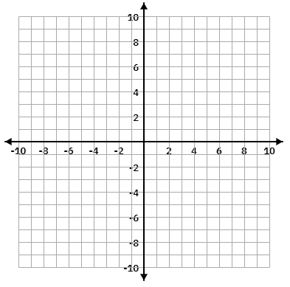
5. $f(x)={\left(x+5\right)}^{3}-2$

6. Graph $y=x$. Graph the function and inverse function. Write the equation of the inverse function.


$f(x)=\sqrt[3]{x-3}+4$

7. If $f(-1)=6$, what would be one point on $f^{-1}(x)$?

8. If $f(5)=-3$, what would be one point on $f^{-1}(x)$?

